Voltage Drop
Student Name

Tool
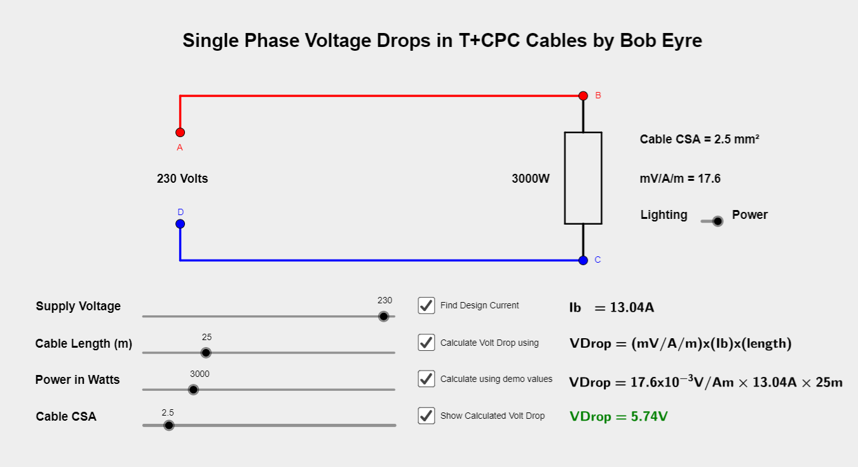
Instruction
When cables carry current to the load of a circuit there will be voltage drop in those cables and across the load that they are feeding. It is beneficial to limit the voltage drop in the cables as this allows the load to work optimally. If you have too high a voltage drop in the cables, less current is available where it is intended, so for example a water heater would take longer to heat a tank of water.
The Regs state that the drop in voltage from the supply to the fixed current using equipment must not exceed 3% for lighting circuits and 5% for other uses of the mains voltage. This means a maximum of 6.9V for lighting and 11.5V for other uses for a 230V installation.
The voltage drop of a circuit may be found from;

Volt Drop = Factor X Design Current X Length of run

- The Factor may be found by looking at the table for the cable type in the Regs or App F of the OSG. Table F6 for 70°C thermoplastic cables has been included via a tab in this tool / in the downloadable file,
- Design Current may be found using the same method as in the previous step of calculating current carrying capacity. E.g, dividing the wattage by the supply voltage.
- Length of run is in metres.
Example
Working through the example given in Linsley pg 159.
An 18m long circuit feeding 6kw worth of lighting has already been calculated as having a Design Current (Ib) of 26.09A and needs a 10mm cable once derating factors have been taken into account.

Volt Drop = Factor X Design Current X Length of run

Volt Drop = 4.4 X 10-3 X 26.09A X 18m = 2.06V

As 2.06V is less than the max permissible value for a lighting circuit (6.9V) then the 10mm cable selected to meet current carrying capacity also satisfies the voltage drop requirements.
Had it not met the voltage drop requirement then the next larger cable of that type should be selected until one is found that does.
As current carrying capacities increase with cable CSA selecting a larger CSA cable to meet volt drop requirements will not result in failing to meet the previously passed current carrying capacity requirement.

Tasks Pt 2
Find the Voltage drop in the following scenarios and state whether or not they meet the voltage drop requirements, recording the calculated voltage drop and max allowable volt drop for each question. All are based on 230V and should use tabulated values (NOT the tools which may use slightly different mV/A/m values for some sizes. These questions take no account of whether or not the cables chosen passed the current carrying capacity requirements.
Find the Voltage drop in the following scenarios and state whether or not they meet the voltage drop requirements, recording the calculated voltage drop and max allowable volt drop for each question. All are based on 230V and should use tabulated values (NOT the tools which may use slightly different mV/A/m values for some sizes. These questions take no account of whether or not the cables chosen passed the current carrying capacity requirements,
- A 9.2kW shower circuit 18m long fed in 10mm 70°C thermoplastic cable.
- A 2kW floodlight circuit which is 40m long fed in 2.5mm 70°C thermoplastic cable.
- A 500W floodlight circuit which is 50m long fed in 1.0mm 70°C thermoplastic cable.
- A 3kW Water heater circuit which is 35m long fed in 2.5mm 70°C thermoplastic cable.
- A 2.2kW heater circuit which is 35m long fed in 2.5mm 70°C thermoplastic cable.
Question | Calculated Volt Drop | Max Permitted Volt Drop | Complies or not
1
2
3
4
5

Find the max allowable length in the following scenarios to meet the voltage drop requirements, recording the length, calculated voltage drop and max allowable volt drop for each question. All are based on 230V and should use tabulated values (NOT the tools which may use slightly different mV/A/m values for some sizes. These questions take no account of whether or not the cables chosen passed the current carrying capacity requirements.

- A 9.2kW shower circuit fed in 10mm 70°C thermoplastic cable.
- A 2.5kW floodlight circuit fed in 2.5mm 70°C thermoplastic cable.
- A 500W floodlight circuit fed in 1.0mm 70°C thermoplastic cable.
- A 500W floodlight circuit fed in 1.5mm 70°C thermoplastic cable.
- A 3kW Water heater circuit fed in 2.5mm 70°C thermoplastic cable.
- A 3kW Water heater circuit fed in 4.0mm 70°C thermoplastic cable.
- A 5kW heater circuit fed in 6.0mm 70°C thermoplastic cable.
- A 8.0kW shower circuit fed in 6.0mm 70°C thermoplastic cable.
- A 8.0kW shower circuit fed in 10.0mm 70°C thermoplastic cable.
- A 1.5kW heater circuit fed in 1.5mm 70°C thermoplastic cable.
Question | Max Length | Calculated Volt Drop | Max Permitted Volt Drop
1
2
3
4
5
6
7
8
9
10
Find the minimum cable size that meets the voltage drop requirements for the following scenarios, recording the cable size, calculated voltage drop and max allowable volt drop for each question. All are based on 230V and should use tabulated values (NOT the tools which may use slightly different mV/A/m values for some sizes. These questions take no account of whether or not the cables chosen passed the current carrying capacity requirements.
- A 9.2kW shower circuit 18m long fed in 70°C thermoplastic cable.
- A 2kW floodlight circuit which is 40m long fed in 70°C thermoplastic cable.
- A 500W floodlight circuit which is 50m long fed in 70°C thermoplastic cable.
- A 3kW Water heater circuit which is 35m long fed in 70°C thermoplastic cable.
- A 2.2kW heater circuit which is 35m long fed in 70°C thermoplastic cable.
Question | Cable Size | Calculated Volt Drop | Max Permitted Volt Drop
1
2
3
4
5

