Earth Fault Loop Path
Student Name

Tool
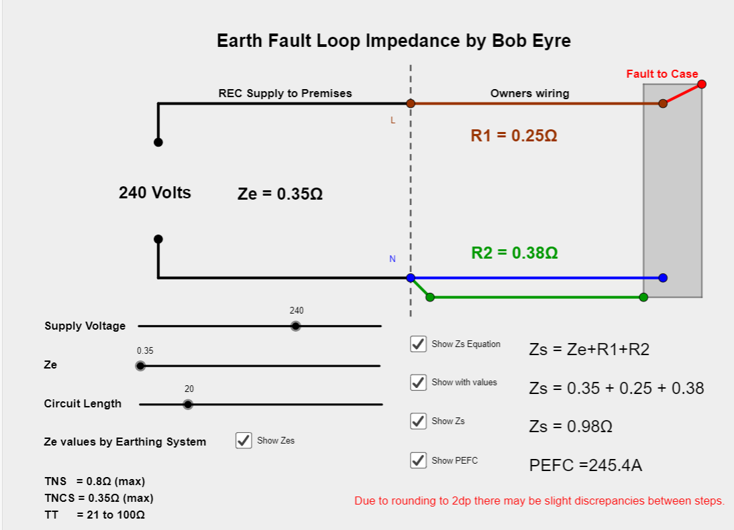
Explanation
Earth Fault Loop Impedance or Zs comprises 3 components
- Ze which is outside of the control of the designer/installer but has general upper limits depending upon the Earthing System feeding the installation.
- R1 (resistance of phase conductor from consumer unit to furthest point on circuit), which is within control of the designer/installer as the CSA and /or length of circuit can be altered.
- R2 (resistance of CPC from consumer unit to furthest point on circuit), which is within control of the designer/installer as the CSA and /or length of circuit can be altered.
As the Zs value increases the Prospective Earth Fault Current decreases and vice versa.
There is a sweet spot or range for each breaker. The Zs value needs to be below an upper limit of Zs in order to create a sufficiently high fault current to operate the fuse or breaker quickly BUT ALSO be above a Xs value that would create too high a fault current that the breaker or fuse is not capable of safely clearing.
In order to disconnect within a given time of 0.4s or 5s a circuit needs to have a sufficiently low Zs value. These max Zs values are dependent upon the type of device and its rating. These values are given in a downloadable table available via the link at the bottom of this page.

Tasks
With supply voltage set to 230V and all checkboxes checked alter the sliders to simulate a variety of scenarios from a very short length circuit fed by a consumer unit in a building fed from TNCS system having a substation close by to a long circuit fed by a TT system. For each one..
- See how the Zs value and Prospective Earth Fault Current (PEFC) change.
- See which of the following sizes of BS60898 type B 6k breakers would be suitable to use, whether they would disconnect within 0.4 secs at that Zs and where not suitable state why and what could be done to protect those circuits. Remember too high a fault current is also an issue.
  - 6A
  - 16A
  - 32A
  - 40A
If not suitable enter a ID number and write notes at end
1 Highest Ze value on TNS system with 1m long circuit.
BS60898 rating | Zs | PEFC | Disc Time | Suitable Y/N?
6A
16A
32A
40A

2 Highest Ze value on TNS system with 10m long circuit.
BS60898 rating | Zs | PEFC | Disc Time | Suitable Y/N?
6A
16A
32A
40A

3 Highest Ze value on TNS system with 100m long circuit.
BS60898 rating | Zs | PEFC | Disc Time | Suitable Y/N?
6A
16A
32A
40A
4 Highest Ze value on TNC-S system with 1m long circuit.
BS60898 rating | Zs | PEFC | Disc Time | Suitable Y/N?
6A
16A
32A
40A

5 Highest Ze value on TNC-S system with 10m long circuit.
BS60898 rating | Zs | PEFC | Disc Time | Suitable Y/N?
6A
16A
32A
40A
6 Highest Ze value on TNC-S system with 100m long circuit.
BS60898 rating | Zs | PEFC | Disc Time | Suitable Y/N?
6A
16A
32A
40A

7 30Ω Ze value on TT system with 10m long circuit.
BS60898 rating | Zs | PEFC | Disc Time | Suitable Y/N?
6A
16A
32A
40A

8 30Ω Ze value on TT system with 30m long circuit.
BS60898 rating | Zs | PEFC | Disc Time | Suitable Y/N?
6A
16A
32A
40A
9 Ze value of 0.01Ω with 100m long circuit.
BS60898 rating | Zs | PEFC | Disc Time | Suitable Y/N?
6A
16A
32A
40A

10 Ze value of 0.01Ω with 50m long circuit.
BS60898 rating | Zs | PEFC | Disc Time | Suitable Y/N?
6A
16A
32A
40A
11 Ze value of 0.01Ω with 2.5m long circuit.
BS60898 rating | Zs | PEFC | Disc Time | Suitable Y/N?
6A
16A
32A
40A

12 Ze value of 0.01Ω with 0.25m long circuit.
BS60898 rating | Zs | PEFC | Disc Time | Suitable Y/N?
6A
16A
32A
40A

Notes
Question | Comment (where relevant)
1
2
3
4
5
6
7
8
9
10
11
12

