Current Carrying Capacity
Student Name

Tool
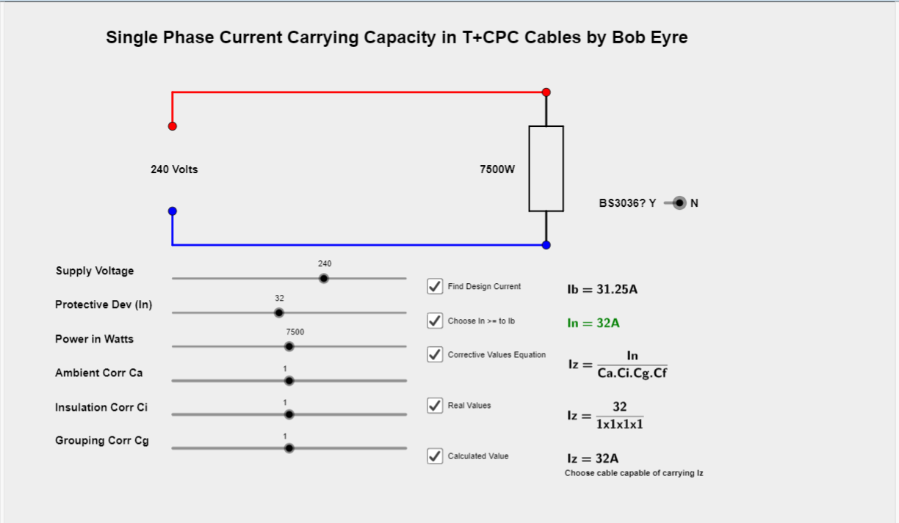
Instruction
Cables heat up when they carry current. They also need to be kept below upper temperature limits. To achieve this various factors such as thermal insulation and their being heated up by neighbouring cables need to be taken into account to make sure they keep below these limits.
This simulator takes the user through the various steps to calculate an appropriate cable CSA for a given scenario. Each step can be hidden or displayed by ticking/unticking various checkboxes.
The steps are:-
- Choose the Wattage and Supply Voltage using the sliders.
- Find the Design Current (Ib) by dividing the wattage by the supply voltage.
- Find a Protective Device that has a rating (In) greater than or equal to the design current in the previous step. Due to the nature of sliders and protective devices not increasing in regular increments the user must choose a valid rating. Until a protective device rating is chosen that exceeds or equals the design current In stays red and prevents subsequent steps & calculations being revealed.
- Look up the factors for ambient temperature, grouping, and thermal insulation thickness from the 18th ed Regs or OSG (or tables displayed by tabs on this page) and adjust the sliders accordingly.
- Adjust the Y/N slider for BS3036 fuse use to the right of the circuit accordingly.
- The simulator now shows how to calculate the cable rating (Iz) by applying these looked up factors to the Protective Device rating (In).
- Now look up the appropriate cable size from the relevant table in the Regs or OSG (or Table F6 via the tabs above).
Tasks Pt 1
Working through the example given in Tanner Book 2 pg 284.
A radial power circuit is to be installed in a surface mounted trunking that contains four other circuits. the circuit is to be wired using single core 70°C thermoplastic-insulated cable with copper conductors. The circuit is 15m in length.
The design current for the single-phase circuit (Ib) is 17A and the ambient temperature is 25°C. Protection against overload and short circuit is by a Type B circuit breaker to BS EN 60898. As In ≥ Ib then a 20A device is selected.
Using the information contained in Appendix 4 of BS 7671: 2018, the installation method is Reference B from Table 4A2.
Ca = 1.03 from Table 4B1 for 25°C and thermoplastic cable.
Cg = 0.6 from Table 4C1, given the number of circuits is five in total, installed as method B.
Ci = 1 as no thermal insulation exists.
Cf = 1 as the device is not to BS 3036.
Adjust the sliders to match the above factors and you should get an Iz of 32.36A.
With the Find Design Current checkbox checked see how the design current changes as the Power in Watts changes.
With the Choose In >= to Ib checkbox checked see how only suitably high ratings can be used.
With the rest of the checkboxes checked and (In) in the green see how various combinations of derating factors can quickly increase the cable size needed.
Tasks Pt 2
Having seen how much difference factors can make on cable size when combined with each other think about how you might work around certain scenarios. For each one work out the design current, protective device rating and cable size and the selected cables current carrying capacity. Assume a supply of 240V. Add comments or suggestions as to how a smaller and therefore cheaper cable may be used or in the case of an existing circuit it could be compliant if it isn’t already.
- A 9.2kW shower circuit is to be installed using 70°C thermoplastic cable run on the surface (clipped direct) through ambient temperatures of 35°C, grouped with 1 other circuit and run through 50mm of thermal insulation.
- An existing 3kW immersion heater fed from a 20A rewireable fuse and wired using 4mm thermoplastic cable run on surface (clipped direct) through ambient temperatures of 30°C, grouped with 4 other circuits and run through 100mm of thermal insulation.
- A circuit feeding six 500w and four 300W floodlights is to be installed using 90°C thermosetting cables run in its own in conduit through no thermal insulation but through an area with an ambient temp of 25°C.
- A 7.5kW shower circuit is to be installed using 70°C thermoplastic cable run on the surface (clipped direct) through ambient temperatures of 25°C. It will be grouped with 1 other circuit and run through 100mm of thermal insulation.
- A circuit feeding seven 500w floodlights is to be installed using 90°C thermosetting cables run in its own in conduit through no thermal insulation but through an area with an ambient temp of 33°C.

